Govt. High School
Sindhi Jamaat Co-Operative Housing Society, Karachi
Parent Teacher Meeting
Total Strength: 56 |  | Class: Level-I
Attendants: 23 |  | Date: 1-2-2025
 |  | Time: 9:00 AM to 12:00 PM

Meeting Agenda:
- 3rd PTM was Conducted on 1 February 2025 for Level-I. (Delay the date 4th January due to Strength of Students).
- These are the following points we are discuss.
- Progress of Students.
- Syllabus.
- Announcement of Annual Exams Date.
- Punctuality.
- Participation in co-curricular Activities
Review:
- 23 parents attended this meeting.
- 96% parents were satisfied with school management and studies.
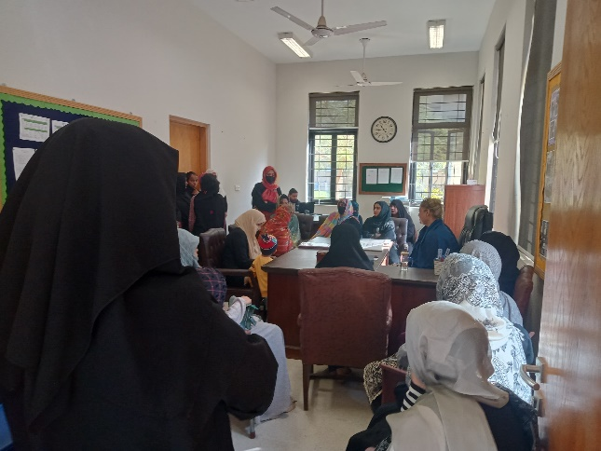
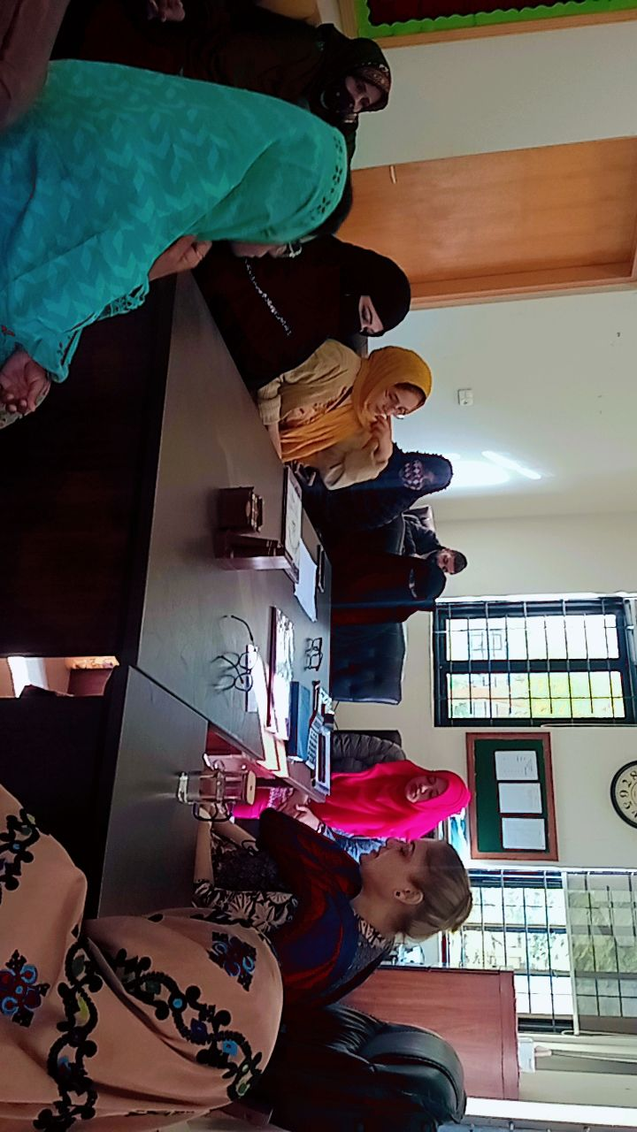
- They assure that they will collaborate with teachers.

